**LICENSE PLATE RECOGNITION SYSTEM**

**MINI PROJECT**

**Submitted in partial fulfilment of the requirement for Degree of Bachelor of Technology in Computer Science & Engineering (AI)**

**Submitted To:**



**DR. A.P.J. ABDUL KALAM TECHNICAL UNIVERSITY, GHAZIABAD (U.P.)**

**Submitted By:**

**DEVANSH DEEPAK-2102901520044**

**ARYAN VASHISTH-2102901520032**

**AKSHANSH MISHRA-2102901520011**

**Under The Guidance Of:**

**Ms Khushboo Saxena**

**Artificial Intelligence Department**



**DEPARTMENT OF COMPUTER SCIENCE & ENGG. (AI)**

**ABESIT GHAZIABAD, UTTAR PRADESH**

**SESSION: 2022-23**

INTRODUCTION

LICENSE PLATE RECOGNITION (or Number Plate Recognition) is a utility based on Optical Character Recognition (OCR).

**OCR** Technology scans paper documents and turns them into electronic editable files.

The LPR “Engine” is a software package where the primary input is an image file containing a license plate, and the primary output is the text of the plate. There are also various other inputs to assist the LPR engine in decoding, and various other outputs as a result of the decoding.

License plate recognition systems (LPRs) use optical character recognition (OCR) algorithms to allow computer software to read vehicle license plates. (These systems are also known as automatic license plate recognition systems, or ALPR.)

LPR systems usually consist of a few basic components:

1. A camera designed to take images of license plates (numbers and letters).

2. A computer software package that interprets the numbers/letters from the video captured by the LPR camera.

3. A database of previously stored “hot lists” or previously read license plates.

A diagram representing functionalities is as follows:

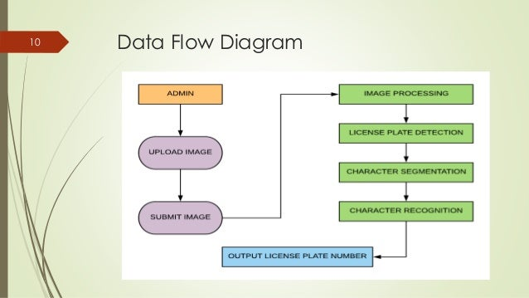

The License Plate data gathered in License Plate Recognition is being employed for a vast range of applications allowing companies and governments to make more intelligent and effective policies, provide better customer service and reduce air pollution at the same time.

Application areas include: Security, Parking, ITS and monitoring, Vehicle Access Control etc.

REVIEW OF LITERATURE

|  |  |  |  |
| --- | --- | --- | --- |
| AUTHOR | TECHNOLOGY | ADVANTAGES | DRAWBACKS |
| Ravina Mithe, Supriya Indalkar, Nilam Divekar | 1. Adaptive Thresholding  2. Component Analysis  3. Acoustic Processing. | 1. This approach is a mobile application having inbuilt camera.  2. It has feature of safety from virus infection | 1. The output from OCR systems is often quite “noisy” and garbled.  2. System requires post processing. |
| Arindam Chaudhauri,Krupa Mandaviya,Pratixa Badelia,Saumya K. Ghosh | 1. Segmentation  2. Feature Extraction  3. Classification | 1. Focused on Offline Handwriting  2. Character Recognition and Document Image Analysis | 1. Limitations for different languages  2. Poor detection  3. Lot of space required by the image produced. |
| Bunke, H Wang, S.K.Chaudhuri | 1. Pattern Recognition  2. Image Acquisition  3.Character  Separation | 1. 100% text searchable documents  2. Disaster Recovery- Data is stored electronically in secured servers and distributed systems. | 1. OCR works efficiently with the printed text only.  2. The quality of image may not be good. |
| Cheriet, M. Kharma, N Liu | 1.Featured Extraction  2.Recognition Algorithms  3.Fuzzy Logic | 1. Cost Reduction  2. High Accuracy Recognition | 1.Sometimes it is inaccurate.  2.You may need to proofread the text after OCR to ensure accuracy. |
| S. V., Nagy, G. Nartker | 1.Matrix Matching  2.Structural Analysis  3.Neural Network | 1.Processing information is fast.  2.The latest software can also create tables accordingly.  3.OCR saves a lot of time in business operations. | 1.Due to OCR, sometimes the formatting of the output documents are lost during the process.  2.This can result in texts that is difficult to read and understand. |

PROBLEM STATEMENT

Automated License Plate Recognition System is the identification system of vehicles. It is an image processing technology used to identify the vehicles only by their license plates.

Automatic Number Plate Recognition ANPR plays a major role in management of parking areas, and surveillance in variety of sectors.

Since every vehicle has a unique number plate so it can be identified by its number plate. The classification is utilized for the electronic toll-collection system (ETC) and to display available parking spaces to vehicles. Thereby a system with high flexibility and better accuracy with increased use cases and simpler algorithms will become handy in accomplishing such tasks and ease up Human work force.

OBJECTIVE

Use of vehicles is getting increased in today’s era that is why traffic control is being tough. It is hard to store and maintain the record of vehicles manually.

Automatic License Plate Recognition System is an essential stage for the automation of traffic system. It can be used for better identification and control of vehicles and for store and maintain the record of vehicles automatically.

**SUB-OBJECTIVES**

* License Plate Recognition and Authorization.
* Checking Details of the vehicle and the Driver.
* Keeping A Semi-Automated record data for vehicles.

METHODOLOGY

1. **Image Processing:** Image Processing includes traditional computer vision methods used to normalize and prepare images for being processed by the OCR algorithm. Since ANPR applications are usually used in challenging real-world environments with varying illumination, occlusion, weather, and inconsistent set-ups, image processing functions are used to sharpen, color-correct, or crop images to significantly improve the results and output of subsequent algorithms.
2. **Image Resizing:** We can resize the image file by a factor of 2x in both the horizontal and vertical directions with the help of **resize**.
3. **Converting to Gray-scale:** Then, we can convert the resized image file to grayscale in order to optimize the detection and reduce the number of colors available in the image drastically, which will allow us to detect the number plates easily.
4. **Denoising the Image:** We can use the Gaussian Blur technique to denoise the images. It makes the edges of the image clearer and smoother, making the characters more readable.

EXPECTED OUTCOMES

A well-built OCR based system with high accuracy, possessing the power to easily identify or recognize the characters of a number plate which can be used for a variety of purposes, such as tracking the movement of vehicles, identifying specific cars, automated parking enforcement, and so on.

REFERENCES

[www.anpr.net](http://www.anpr.net)

en.wikipedia.org

<https://viso.ai/computer-vision/automatic-number-plate-recognition-anpr/>

https://www.javatpoint.com